CC1

QUESTION 1:

Adding a product to cart and checkout :

Verify that user is able to add a product to the cart Add to cart

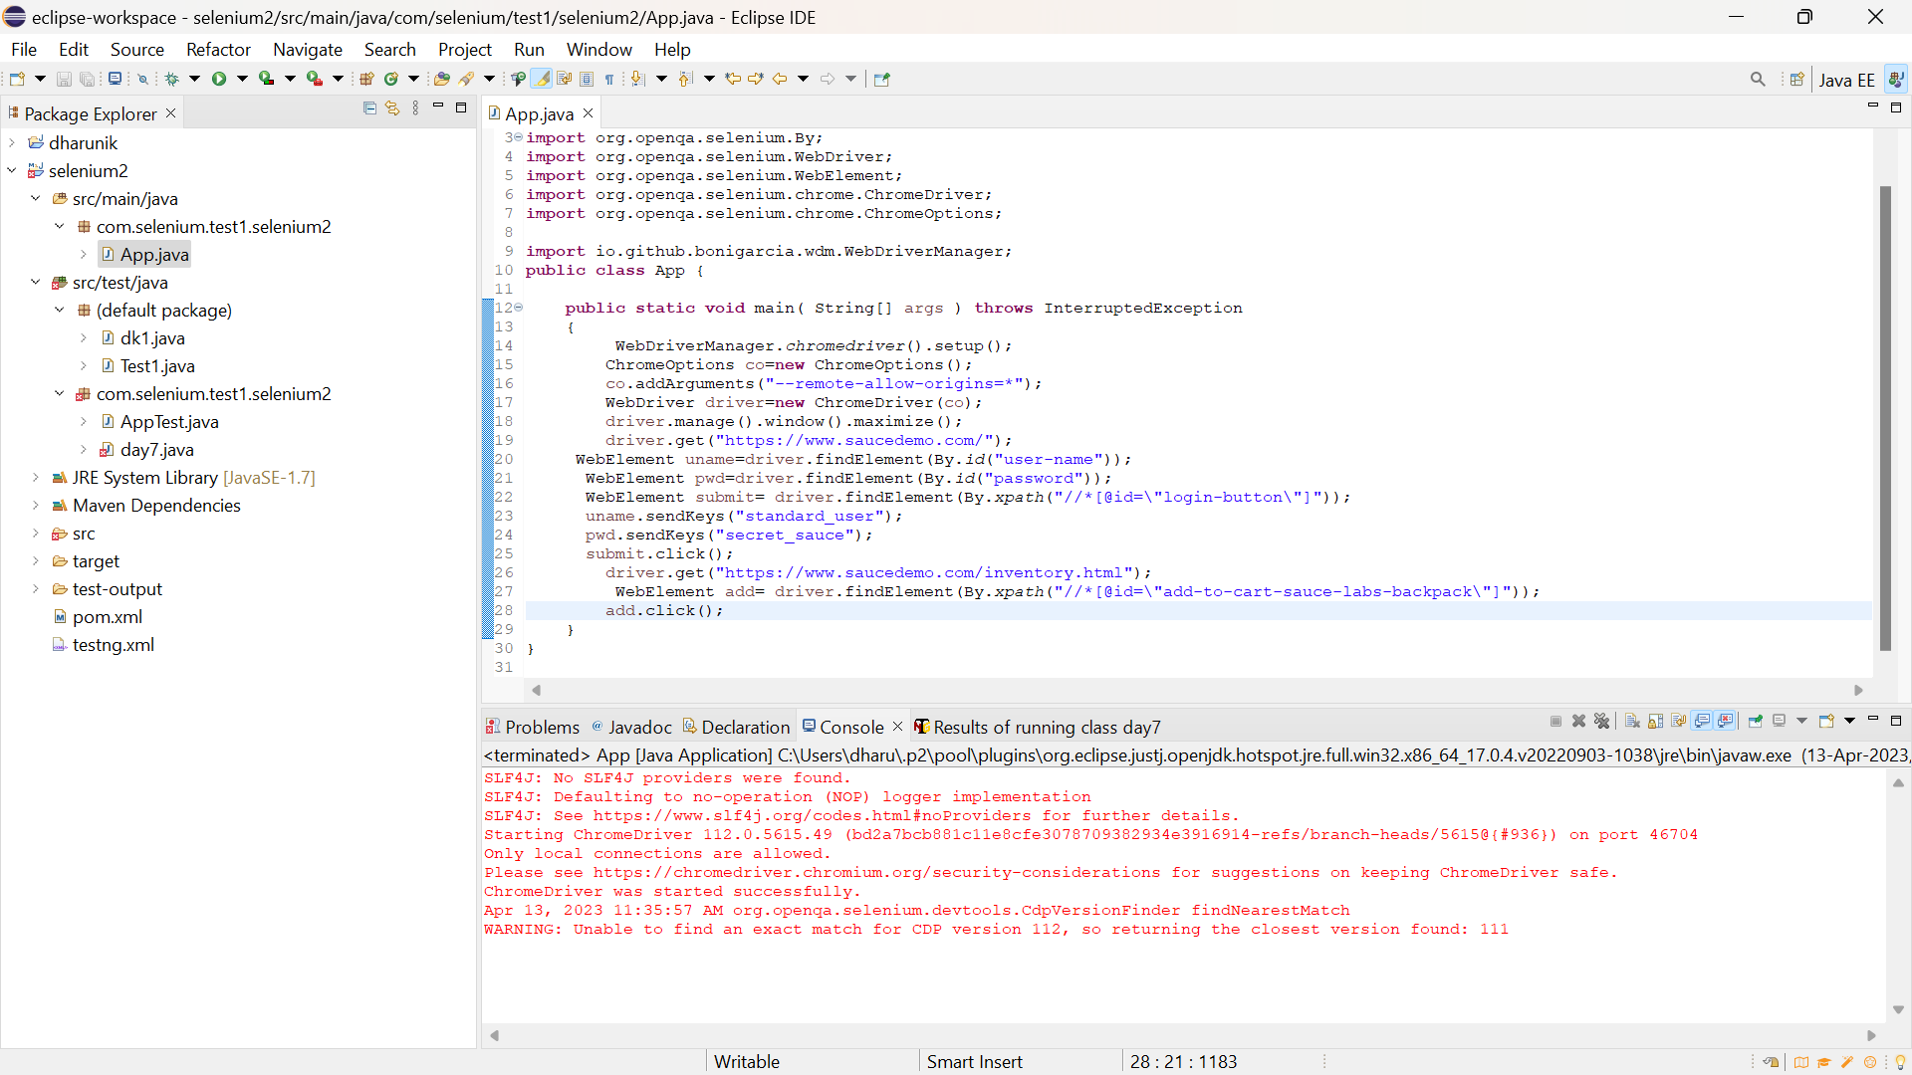

**package** com.selenium.test1.selenium2;

**import** org.openqa.selenium.By;

**import** org.openqa.selenium.WebDriver;

**import** org.openqa.selenium.WebElement;

**import** org.openqa.selenium.chrome.ChromeDriver;

**import** org.openqa.selenium.chrome.ChromeOptions;

**import** io.github.bonigarcia.wdm.WebDriverManager;

**public** **class** App {

**public** **static** **void** main( String[] args ) **throws** InterruptedException

{

WebDriverManager.*chromedriver*().setup();

ChromeOptions co=**new** ChromeOptions();

co.addArguments("--remote-allow-origins=*");

WebDriver driver=**new** ChromeDriver(co);

driver.manage().window().maximize();

driver.get("https://www.saucedemo.com/");

WebElement uname=driver.findElement(By.*id*("user-name"));

WebElement pwd=driver.findElement(By.*id*("password"));

WebElement submit= driver.findElement(By.*xpath*("//*[@id=\"login-button\"]"));

uname.sendKeys("standard_user");

pwd.sendKeys("secret_sauce");

submit.click();

driver.get("https://www.saucedemo.com/inventory.html");

WebElement add= driver.findElement(By.*xpath*("//*[@id=\"add-to-cart-sauce-labs-backpack\"]"));

add.click();

}

}

Verify that user can view the contents in the cart

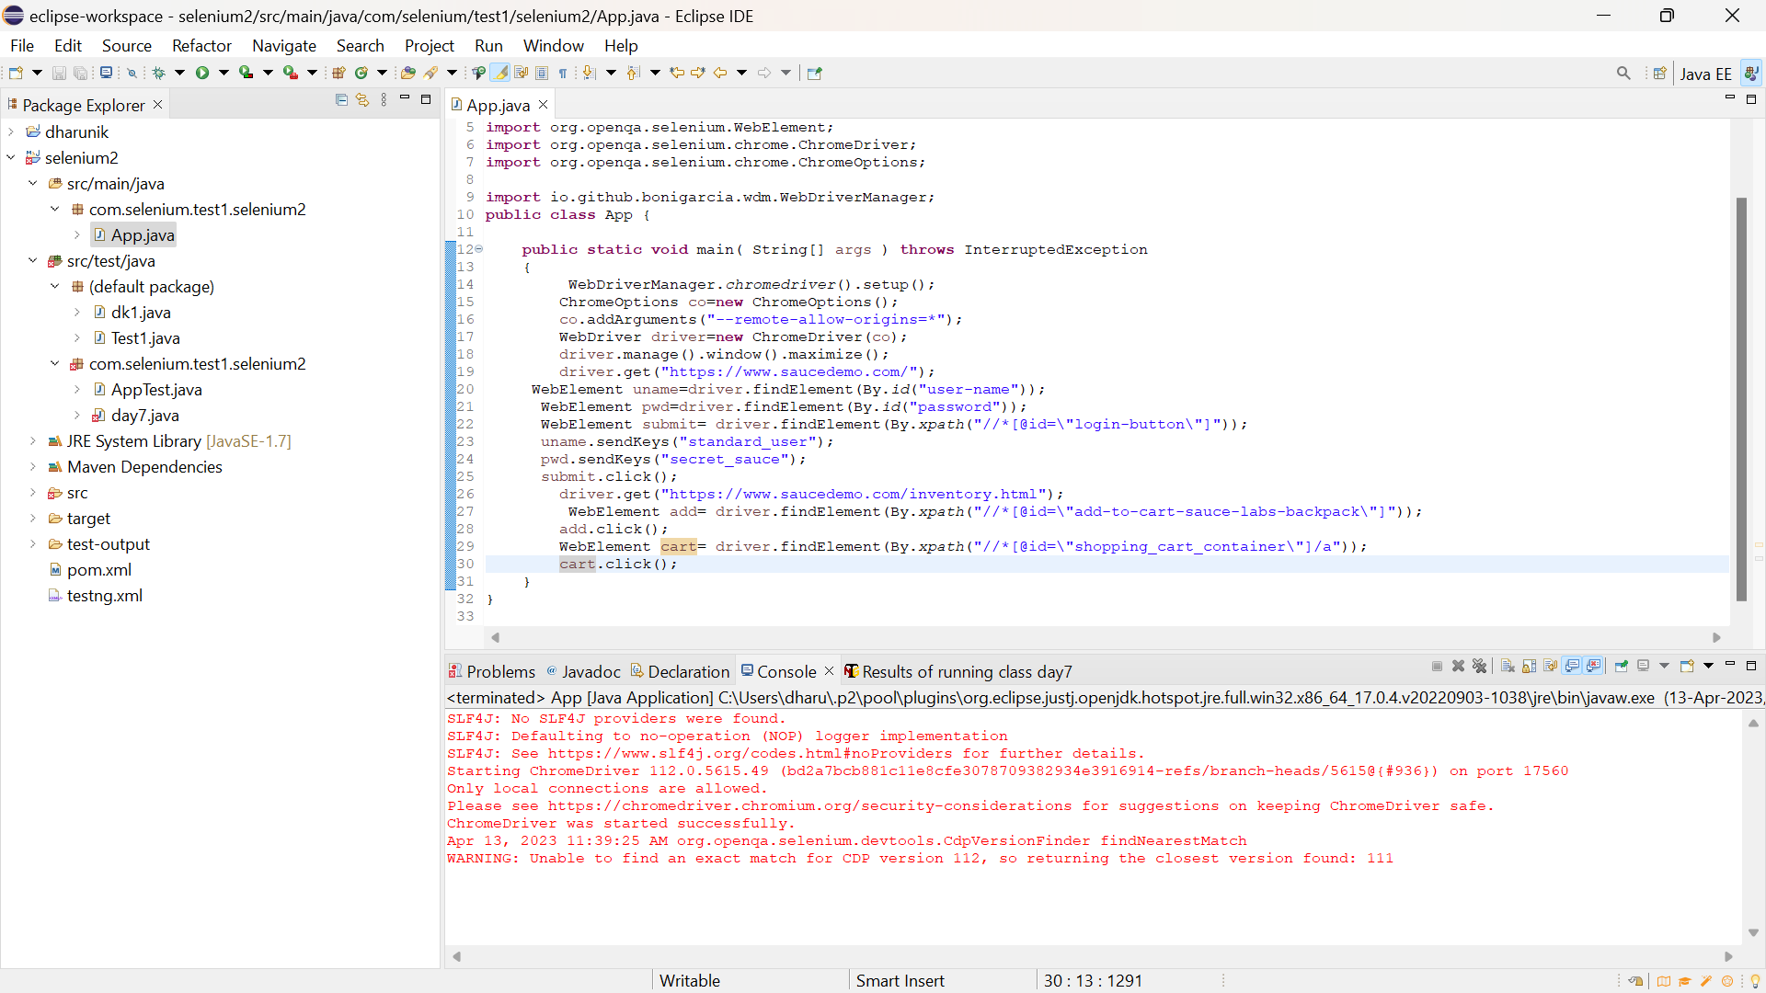

**package** com.selenium.test1.selenium2;

**import** org.openqa.selenium.By;

**import** org.openqa.selenium.WebDriver;

**import** org.openqa.selenium.WebElement;

**import** org.openqa.selenium.chrome.ChromeDriver;

**import** org.openqa.selenium.chrome.ChromeOptions;

**import** io.github.bonigarcia.wdm.WebDriverManager;

**public** **class** App {

**public** **static** **void** main( String[] args ) **throws** InterruptedException

{

WebDriverManager.*chromedriver*().setup();

ChromeOptions co=**new** ChromeOptions();

co.addArguments("--remote-allow-origins=*");

WebDriver driver=**new** ChromeDriver(co);

driver.manage().window().maximize();

driver.get("https://www.saucedemo.com/");

WebElement uname=driver.findElement(By.*id*("user-name"));

WebElement pwd=driver.findElement(By.*id*("password"));

WebElement submit= driver.findElement(By.*xpath*("//*[@id=\"login-button\"]"));

uname.sendKeys("standard_user");

pwd.sendKeys("secret_sauce");

submit.click();

driver.get("https://www.saucedemo.com/inventory.html");

WebElement add= driver.findElement(By.*xpath*("//*[@id=\"add-to-cart-sauce-labs-backpack\"]"));

add.click();

WebElement cart= driver.findElement(By.*xpath*("//*[@id=\"shopping_cart_container\"]/a"));

cart.click();

}

}

Verify that once user clicks on checkout button “Your information” form should be displayed

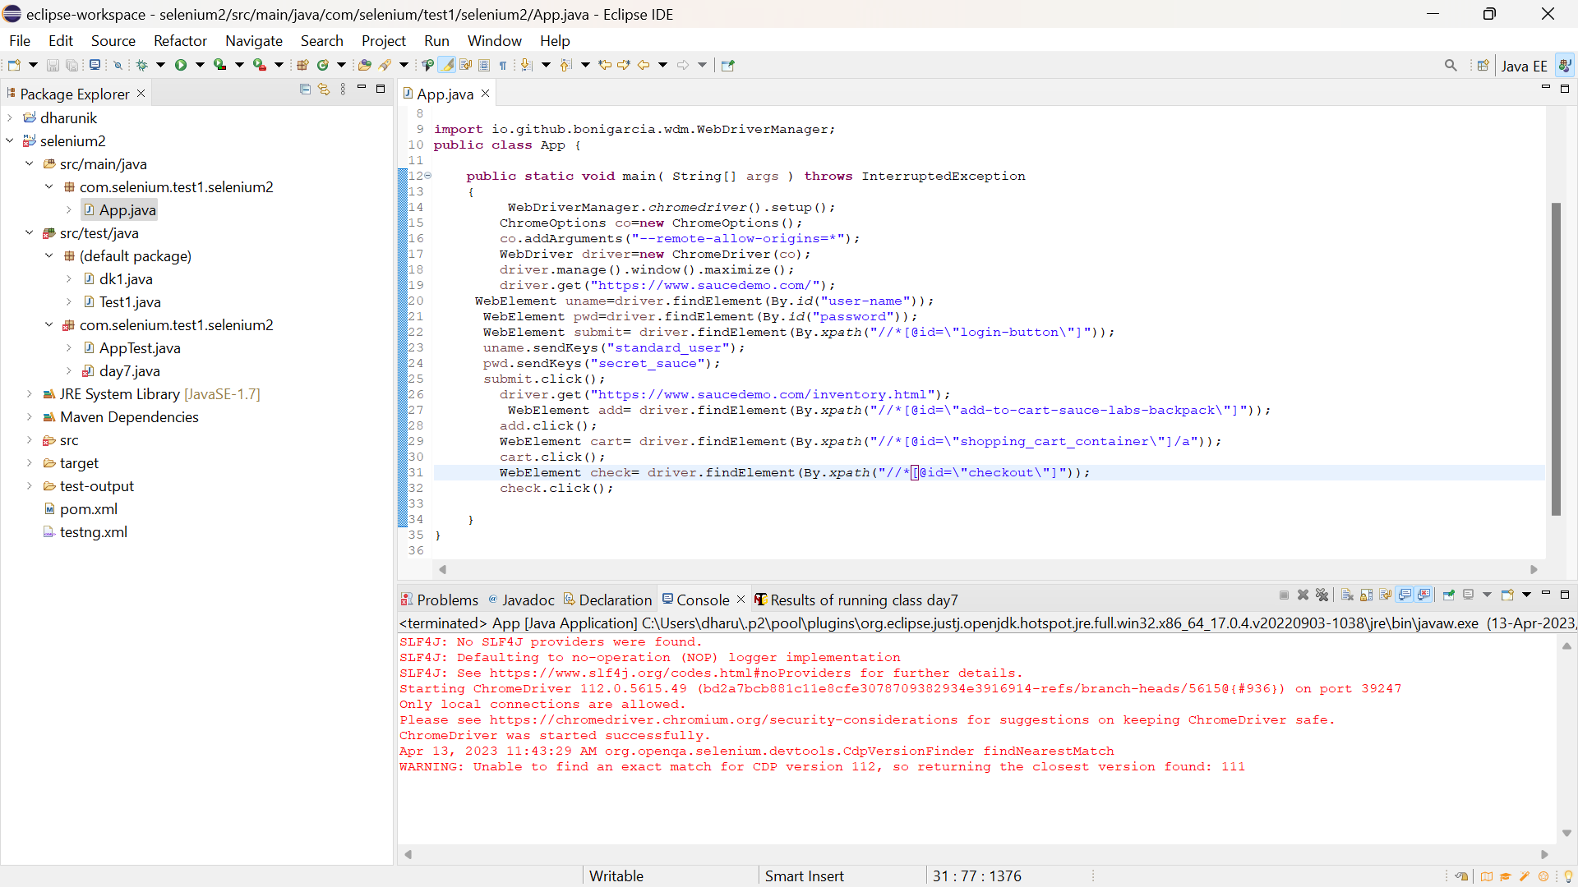

**package** com.selenium.test1.selenium2;

**import** org.openqa.selenium.By;

**import** org.openqa.selenium.WebDriver;

**import** org.openqa.selenium.WebElement;

**import** org.openqa.selenium.chrome.ChromeDriver;

**import** org.openqa.selenium.chrome.ChromeOptions;

**import** io.github.bonigarcia.wdm.WebDriverManager;

**public** **class** App {

**public** **static** **void** main( String[] args ) **throws** InterruptedException

{

WebDriverManager.*chromedriver*().setup();

ChromeOptions co=**new** ChromeOptions();

co.addArguments("--remote-allow-origins=*");

WebDriver driver=**new** ChromeDriver(co);

driver.manage().window().maximize();

driver.get("https://www.saucedemo.com/");

WebElement uname=driver.findElement(By.*id*("user-name"));

WebElement pwd=driver.findElement(By.*id*("password"));

WebElement submit= driver.findElement(By.*xpath*("//*[@id=\"login-button\"]"));

uname.sendKeys("standard_user");

pwd.sendKeys("secret_sauce");

submit.click();

driver.get("https://www.saucedemo.com/inventory.html");

WebElement add= driver.findElement(By.*xpath*("//*[@id=\"add-to-cart-sauce-labs-backpack\"]"));

add.click();

WebElement cart= driver.findElement(By.*xpath*("//*[@id=\"shopping_cart_container\"]/a"));

cart.click();

WebElement check= driver.findElement(By.*xpath*("//*[@id=\"checkout\"]"));

check.click();

}

}

• Verify that once user fills the form and clicks on continue button entire product overview should be displayed

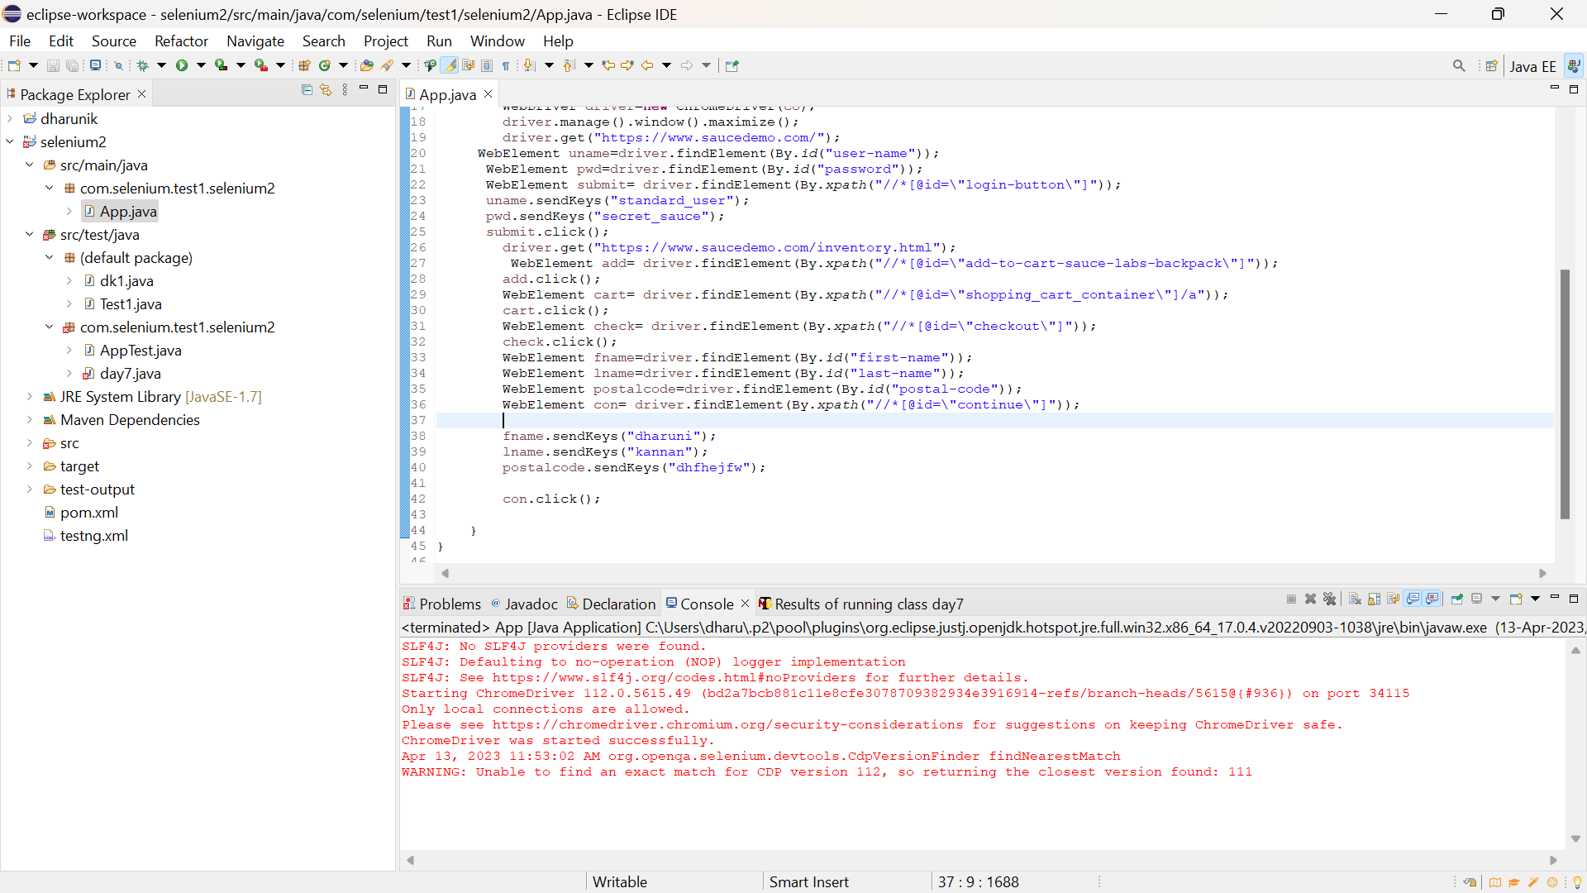

**package** com.selenium.test1.selenium2;

**import** org.openqa.selenium.By;

**import** org.openqa.selenium.WebDriver;

**import** org.openqa.selenium.WebElement;

**import** org.openqa.selenium.chrome.ChromeDriver;

**import** org.openqa.selenium.chrome.ChromeOptions;

**import** io.github.bonigarcia.wdm.WebDriverManager;

**public** **class** App {

**public** **static** **void** main( String[] args ) **throws** InterruptedException

{

WebDriverManager.*chromedriver*().setup();

ChromeOptions co=**new** ChromeOptions();

co.addArguments("--remote-allow-origins=*");

WebDriver driver=**new** ChromeDriver(co);

driver.manage().window().maximize();

driver.get("https://www.saucedemo.com/");

WebElement uname=driver.findElement(By.*id*("user-name"));

WebElement pwd=driver.findElement(By.*id*("password"));

WebElement submit= driver.findElement(By.*xpath*("//*[@id=\"login-button\"]"));

uname.sendKeys("standard_user");

pwd.sendKeys("secret_sauce");

submit.click();

driver.get("https://www.saucedemo.com/inventory.html");

WebElement add= driver.findElement(By.*xpath*("//*[@id=\"add-to-cart-sauce-labs-backpack\"]"));

add.click();

WebElement cart= driver.findElement(By.*xpath*("//*[@id=\"shopping_cart_container\"]/a"));

cart.click();

WebElement check= driver.findElement(By.*xpath*("//*[@id=\"checkout\"]"));

check.click();

WebElement fname=driver.findElement(By.*id*("first-name"));

WebElement lname=driver.findElement(By.*id*("last-name"));

WebElement postalcode=driver.findElement(By.*id*("postal-code"));

WebElement con= driver.findElement(By.*xpath*("//*[@id=\"continue\"]"));

fname.sendKeys("dharuni");

lname.sendKeys("kannan");

postalcode.sendKeys("dhfhejfw");

con.click();

}

}

Print the name of the product and the price of the product

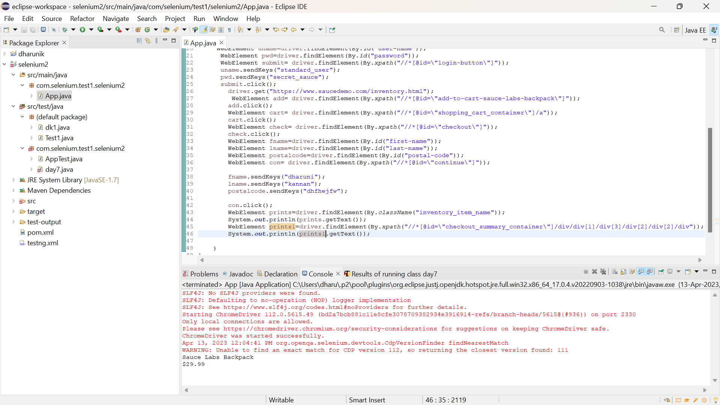

**package** com.selenium.test1.selenium2;

**import** org.openqa.selenium.By;

**import** org.openqa.selenium.WebDriver;

**import** org.openqa.selenium.WebElement;

**import** org.openqa.selenium.chrome.ChromeDriver;

**import** org.openqa.selenium.chrome.ChromeOptions;

**import** io.github.bonigarcia.wdm.WebDriverManager;

**public** **class** App {

**public** **static** **void** main( String[] args ) **throws** InterruptedException

{

WebDriverManager.*chromedriver*().setup();

ChromeOptions co=**new** ChromeOptions();

co.addArguments("--remote-allow-origins=*");

WebDriver driver=**new** ChromeDriver(co);

driver.manage().window().maximize();

driver.get("https://www.saucedemo.com/");

WebElement uname=driver.findElement(By.*id*("user-name"));

WebElement pwd=driver.findElement(By.*id*("password"));

WebElement submit= driver.findElement(By.*xpath*("//*[@id=\"login-button\"]"));

uname.sendKeys("standard_user");

pwd.sendKeys("secret_sauce");

submit.click();

driver.get("https://www.saucedemo.com/inventory.html");

WebElement add= driver.findElement(By.*xpath*("//*[@id=\"add-to-cart-sauce-labs-backpack\"]"));

add.click();

WebElement cart= driver.findElement(By.*xpath*("//*[@id=\"shopping_cart_container\"]/a"));

cart.click();

WebElement check= driver.findElement(By.*xpath*("//*[@id=\"checkout\"]"));

check.click();

WebElement fname=driver.findElement(By.*id*("first-name"));

WebElement lname=driver.findElement(By.*id*("last-name"));

WebElement postalcode=driver.findElement(By.*id*("postal-code"));

WebElement con= driver.findElement(By.*xpath*("//*[@id=\"continue\"]"));

fname.sendKeys("dharuni");

lname.sendKeys("kannan");

postalcode.sendKeys("dhfhejfw");

con.click();

WebElement prints=driver.findElement(By.*className*("inventory_item_name"));

System.***out***.println(prints.getText());

WebElement prints1=driver.findElement(By.*xpath*("//*[@id=\"checkout_summary_container\"]/div/div[1]/div[3]/div[2]/div[2]/div"));

System.***out***.println(prints1.getText());

}

}

Assert the title of the page is ‘Swag Labs’

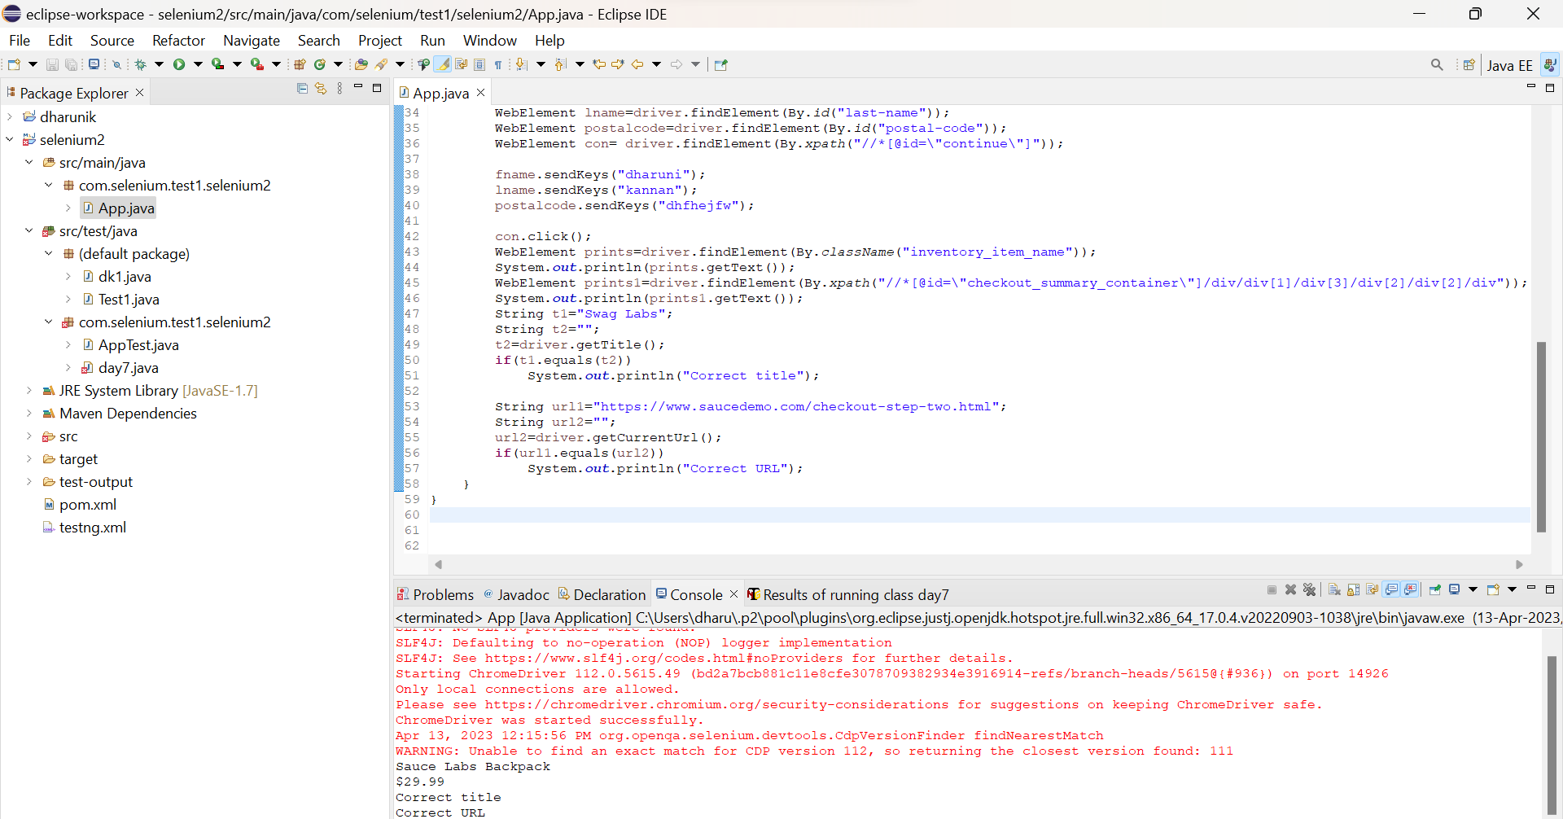

**package** com.selenium.test1.selenium2;

**import** org.openqa.selenium.By;

**import** org.openqa.selenium.WebDriver;

**import** org.openqa.selenium.WebElement;

**import** org.openqa.selenium.chrome.ChromeDriver;

**import** org.openqa.selenium.chrome.ChromeOptions;

**import** io.github.bonigarcia.wdm.WebDriverManager;

**public** **class** App {

**public** **static** **void** main( String[] args ) **throws** InterruptedException

{

WebDriverManager.*chromedriver*().setup();

ChromeOptions co=**new** ChromeOptions();

co.addArguments("--remote-allow-origins=*");

WebDriver driver=**new** ChromeDriver(co);

driver.manage().window().maximize();

driver.get("https://www.saucedemo.com/");

WebElement uname=driver.findElement(By.*id*("user-name"));

WebElement pwd=driver.findElement(By.*id*("password"));

WebElement submit= driver.findElement(By.*xpath*("//*[@id=\"login-button\"]"));

uname.sendKeys("standard_user");

pwd.sendKeys("secret_sauce");

submit.click();

driver.get("https://www.saucedemo.com/inventory.html");

WebElement add= driver.findElement(By.*xpath*("//*[@id=\"add-to-cart-sauce-labs-backpack\"]"));

add.click();

WebElement cart= driver.findElement(By.*xpath*("//*[@id=\"shopping_cart_container\"]/a"));

cart.click();

WebElement check= driver.findElement(By.*xpath*("//*[@id=\"checkout\"]"));

check.click();

WebElement fname=driver.findElement(By.*id*("first-name"));

WebElement lname=driver.findElement(By.*id*("last-name"));

WebElement postalcode=driver.findElement(By.*id*("postal-code"));

WebElement con= driver.findElement(By.*xpath*("//*[@id=\"continue\"]"));

fname.sendKeys("dharuni");

lname.sendKeys("kannan");

postalcode.sendKeys("dhfhejfw");

con.click();

WebElement prints=driver.findElement(By.*className*("inventory_item_name"));

System.***out***.println(prints.getText());

WebElement prints1=driver.findElement(By.*xpath*("//*[@id=\"checkout_summary_container\"]/div/div[1]/div[3]/div[2]/div[2]/div"));

System.***out***.println(prints1.getText());

String t1="Swag Labs";

String t2="";

t2=driver.getTitle();

**if**(t1.equals(t2))

System.***out***.println("Correct title");

String url1="https://www.saucedemo.com/checkout-step-two.html";

String url2="";

url2=driver.getCurrentUrl();

**if**(url1.equals(url2))

System.***out***.println("Correct URL");

}

}

QUESTION 2:

Filter option :

• Verify that user is able to apply filter name wise from A-Z and Z-A

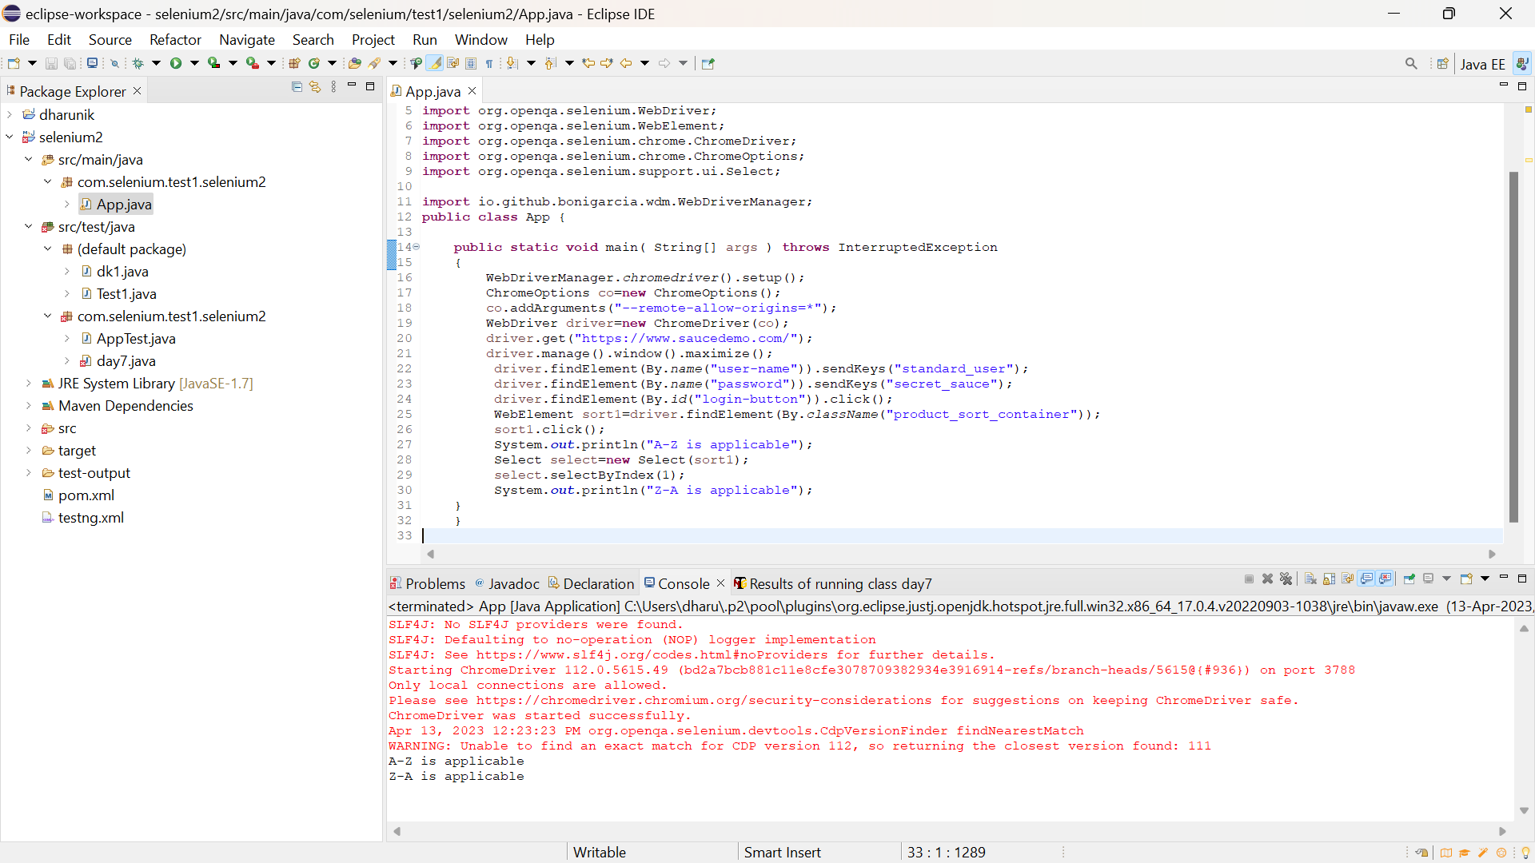

**package** com.selenium.test1.selenium2;

**import** org.openqa.selenium.By;

**import** org.openqa.selenium.JavascriptExecutor;

**import** org.openqa.selenium.WebDriver;

**import** org.openqa.selenium.WebElement;

**import** org.openqa.selenium.chrome.ChromeDriver;

**import** org.openqa.selenium.chrome.ChromeOptions;

**import** org.openqa.selenium.support.ui.Select;

**import** io.github.bonigarcia.wdm.WebDriverManager;

**public** **class** App {

**public** **static** **void** main( String[] args ) **throws** InterruptedException

{

WebDriverManager.*chromedriver*().setup();

ChromeOptions co=**new** ChromeOptions();

co.addArguments("--remote-allow-origins=*");

WebDriver driver=**new** ChromeDriver(co);

driver.get("https://www.saucedemo.com/");

driver.manage().window().maximize();

driver.findElement(By.*name*("user-name")).sendKeys("standard_user");

driver.findElement(By.*name*("password")).sendKeys("secret_sauce");

driver.findElement(By.*id*("login-button")).click();

WebElement sort1=driver.findElement(By.*className*("product_sort_container"));

sort1.click();

System.***out***.println("A-Z is applicable");

Select select=**new** Select(sort1);

select.selectByIndex(1);

System.***out***.println("Z-A is applicable");

}

}

Print the first product name while filtering from A-Z and print 1st product name while filtering from Z-A

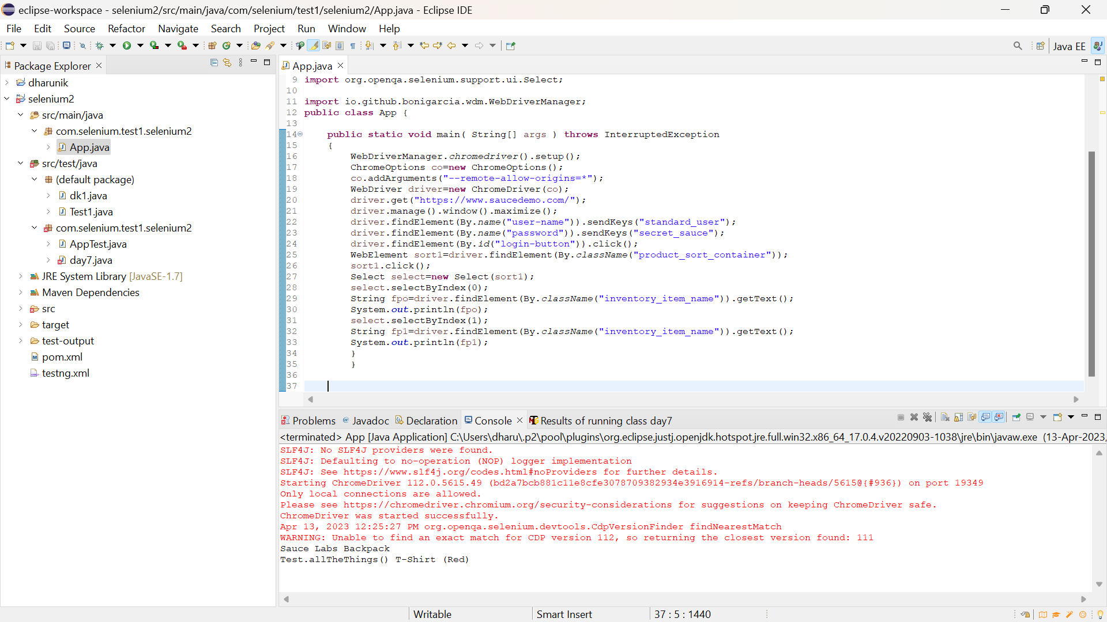

**package** com.selenium.test1.selenium2;

**import** org.openqa.selenium.By;

**import** org.openqa.selenium.JavascriptExecutor;

**import** org.openqa.selenium.WebDriver;

**import** org.openqa.selenium.WebElement;

**import** org.openqa.selenium.chrome.ChromeDriver;

**import** org.openqa.selenium.chrome.ChromeOptions;

**import** org.openqa.selenium.support.ui.Select;

**import** io.github.bonigarcia.wdm.WebDriverManager;

**public** **class** App {

**public** **static** **void** main( String[] args ) **throws** InterruptedException

{

WebDriverManager.*chromedriver*().setup();

ChromeOptions co=**new** ChromeOptions();

co.addArguments("--remote-allow-origins=*");

WebDriver driver=**new** ChromeDriver(co);

driver.get("https://www.saucedemo.com/");

driver.manage().window().maximize();

driver.findElement(By.*name*("user-name")).sendKeys("standard_user");

driver.findElement(By.*name*("password")).sendKeys("secret_sauce");

driver.findElement(By.*id*("login-button")).click();

WebElement sort1=driver.findElement(By.*className*("product_sort_container"));

sort1.click();

Select select=**new** Select(sort1);

select.selectByIndex(0);

String fpo=driver.findElement(By.*className*("inventory_item_name")).getText();

System.***out***.println(fpo);

select.selectByIndex(1);

String fp1=driver.findElement(By.*className*("inventory_item_name")).getText();

System.***out***.println(fp1);

}

}

Verify the user is able to apply filter from low price to high price and high price to low price

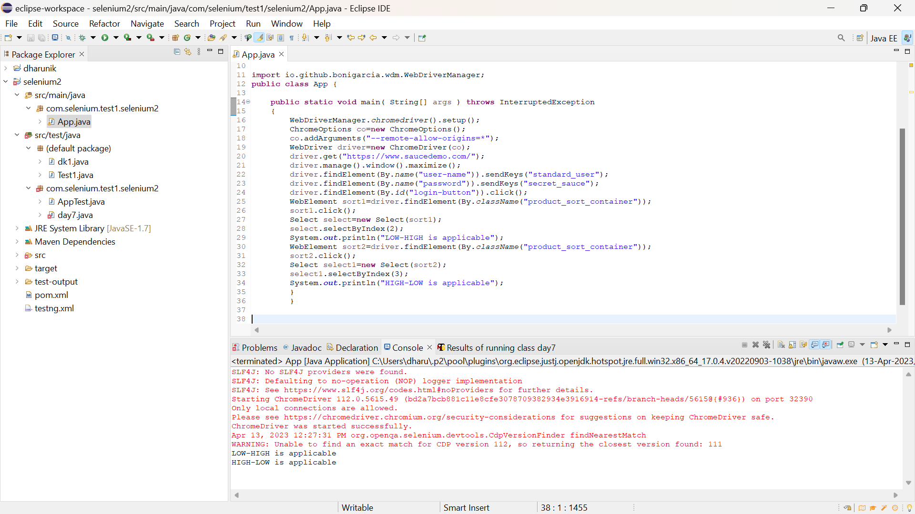

**package** com.selenium.test1.selenium2;

**import** org.openqa.selenium.By;

**import** org.openqa.selenium.JavascriptExecutor;

**import** org.openqa.selenium.WebDriver;

**import** org.openqa.selenium.WebElement;

**import** org.openqa.selenium.chrome.ChromeDriver;

**import** org.openqa.selenium.chrome.ChromeOptions;

**import** org.openqa.selenium.support.ui.Select;

**import** io.github.bonigarcia.wdm.WebDriverManager;

**public** **class** App {

**public** **static** **void** main( String[] args ) **throws** InterruptedException

{

WebDriverManager.*chromedriver*().setup();

ChromeOptions co=**new** ChromeOptions();

co.addArguments("--remote-allow-origins=*");

WebDriver driver=**new** ChromeDriver(co);

driver.get("https://www.saucedemo.com/");

driver.manage().window().maximize();

driver.findElement(By.*name*("user-name")).sendKeys("standard_user");

driver.findElement(By.*name*("password")).sendKeys("secret_sauce");

driver.findElement(By.*id*("login-button")).click();

WebElement sort1=driver.findElement(By.*className*("product_sort_container"));

sort1.click();

Select select=**new** Select(sort1);

select.selectByIndex(2);

System.***out***.println("LOW-HIGH is applicable");

WebElement sort2=driver.findElement(By.*className*("product_sort_container"));

sort2.click();

Select select1=**new** Select(sort2);

select1.selectByIndex(3);

System.***out***.println("HIGH-LOW is applicable");

}

}

Print the 1 st product price while filtering from high to low and print 1st product price while filtering from low to high

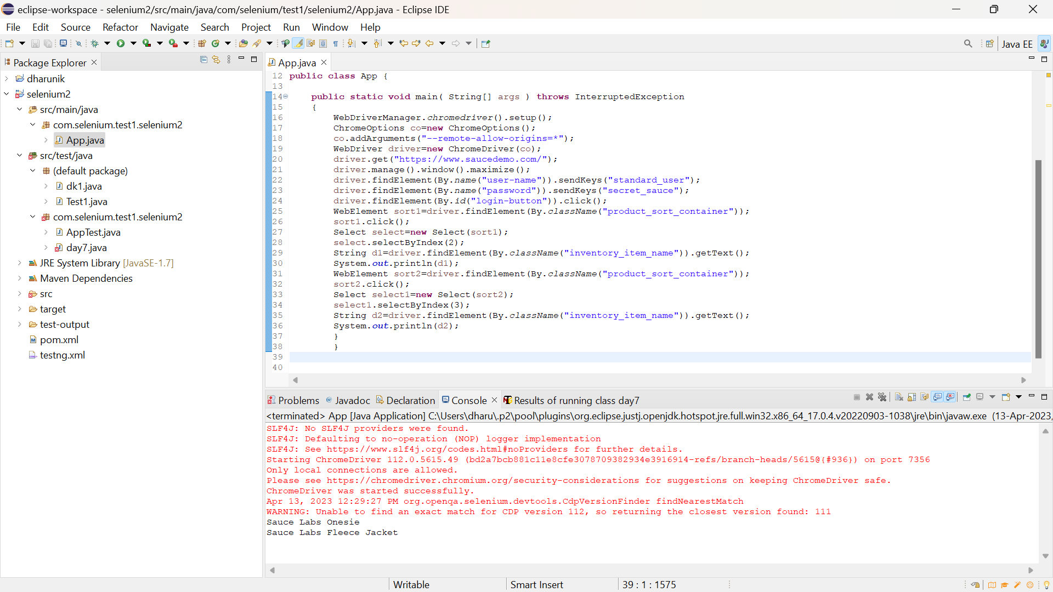

**package** com.selenium.test1.selenium2;

**import** org.openqa.selenium.By;

**import** org.openqa.selenium.JavascriptExecutor;

**import** org.openqa.selenium.WebDriver;

**import** org.openqa.selenium.WebElement;

**import** org.openqa.selenium.chrome.ChromeDriver;

**import** org.openqa.selenium.chrome.ChromeOptions;

**import** org.openqa.selenium.support.ui.Select;

**import** io.github.bonigarcia.wdm.WebDriverManager;

**public** **class** App {

**public** **static** **void** main( String[] args ) **throws** InterruptedException

{

WebDriverManager.*chromedriver*().setup();

ChromeOptions co=**new** ChromeOptions();

co.addArguments("--remote-allow-origins=*");

WebDriver driver=**new** ChromeDriver(co);

driver.get("https://www.saucedemo.com/");

driver.manage().window().maximize();

driver.findElement(By.*name*("user-name")).sendKeys("standard_user");

driver.findElement(By.*name*("password")).sendKeys("secret_sauce");

driver.findElement(By.*id*("login-button")).click();

WebElement sort1=driver.findElement(By.*className*("product_sort_container"));

sort1.click();

Select select=**new** Select(sort1);

select.selectByIndex(2);

String d1=driver.findElement(By.*className*("inventory_item_name")).getText();

System.***out***.println(d1);

WebElement sort2=driver.findElement(By.*className*("product_sort_container"));

sort2.click();

Select select1=**new** Select(sort2);

select1.selectByIndex(3);

String d2=driver.findElement(By.*className*("inventory_item_name")).getText();

System.***out***.println(d2);

}

}